AI Assisted Coding
M. Sprusheeth Rao
2303A51206
Batch - 04
07-01-2026

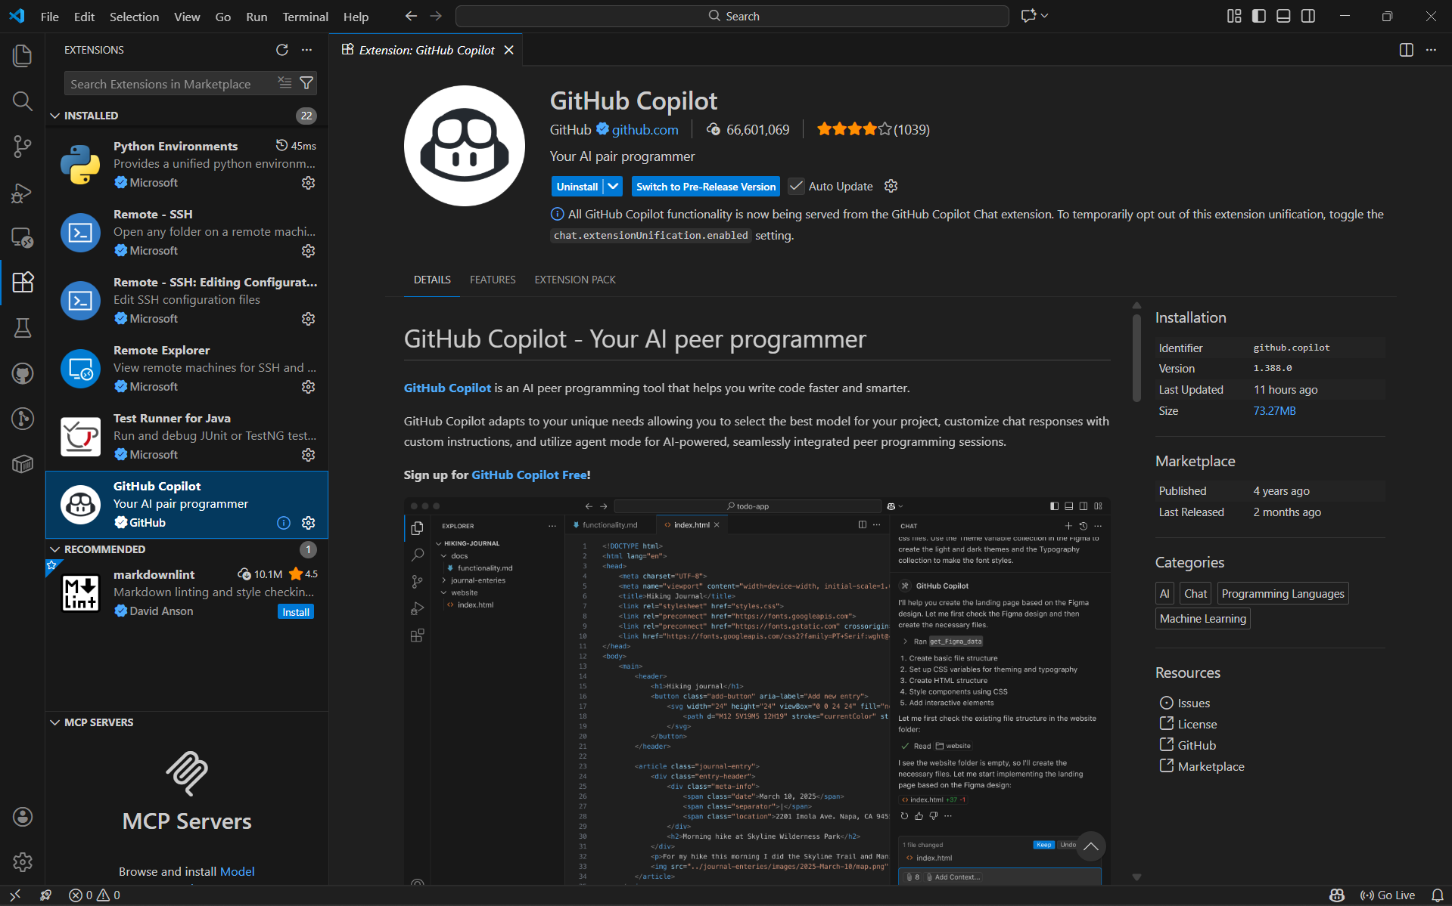

Task 0: Environment Setup:-

Task 1: AI-Generated Logic Without Modularization (Factorial without
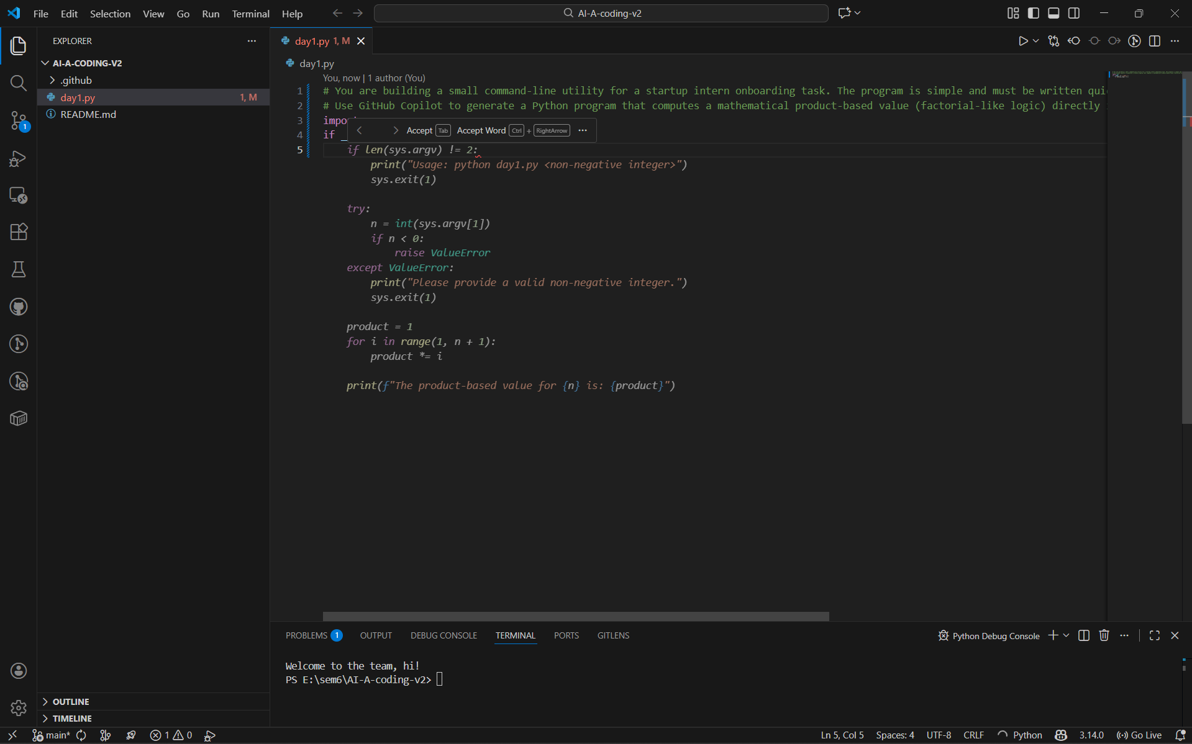
Functions)
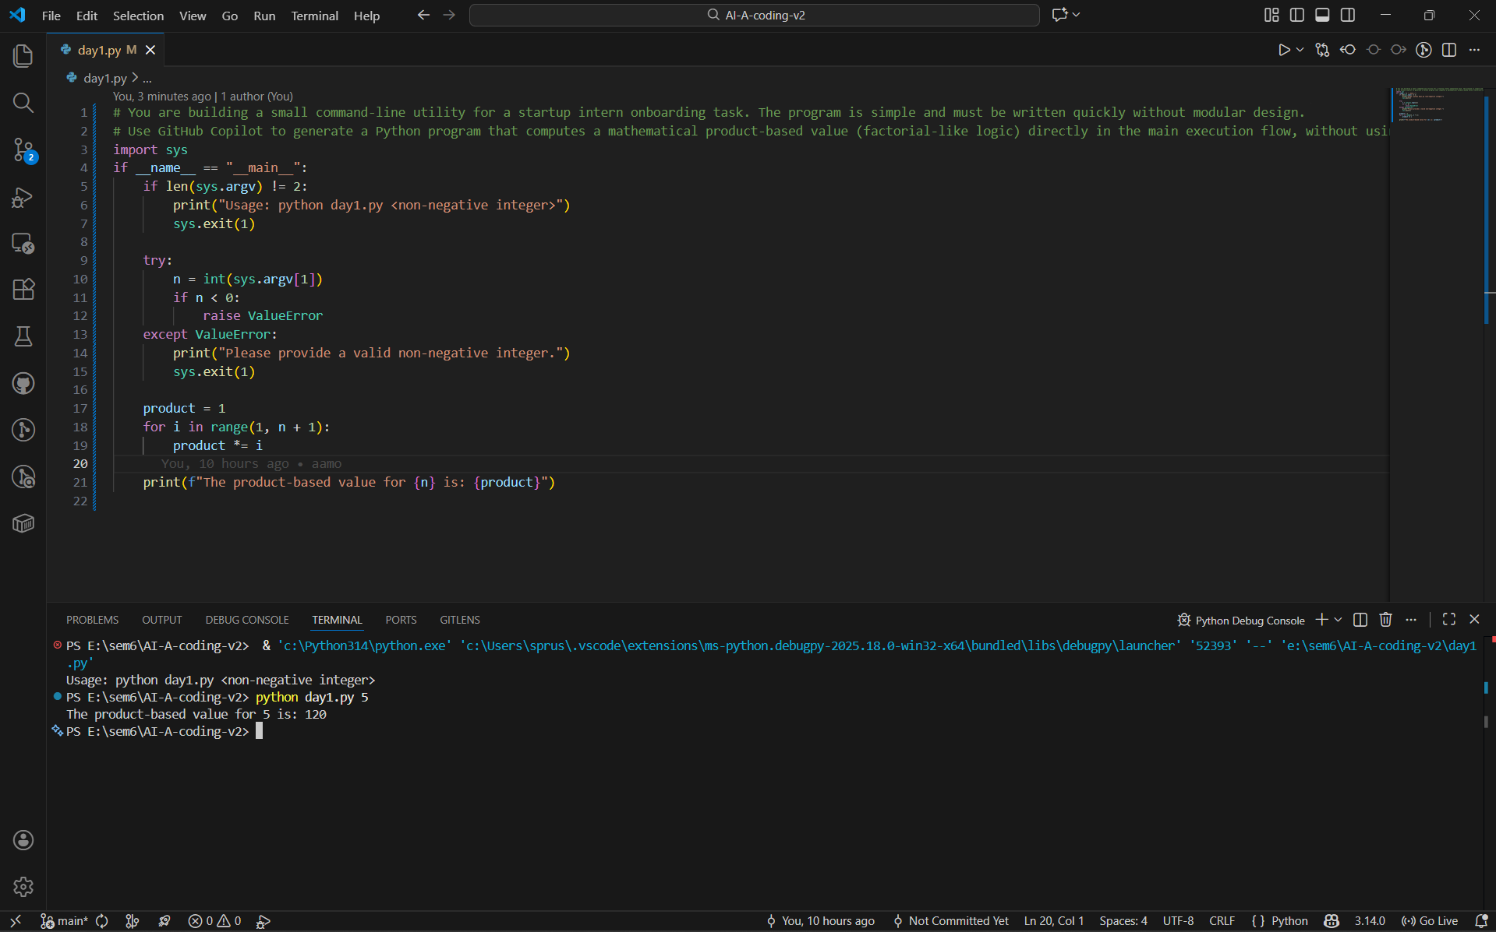

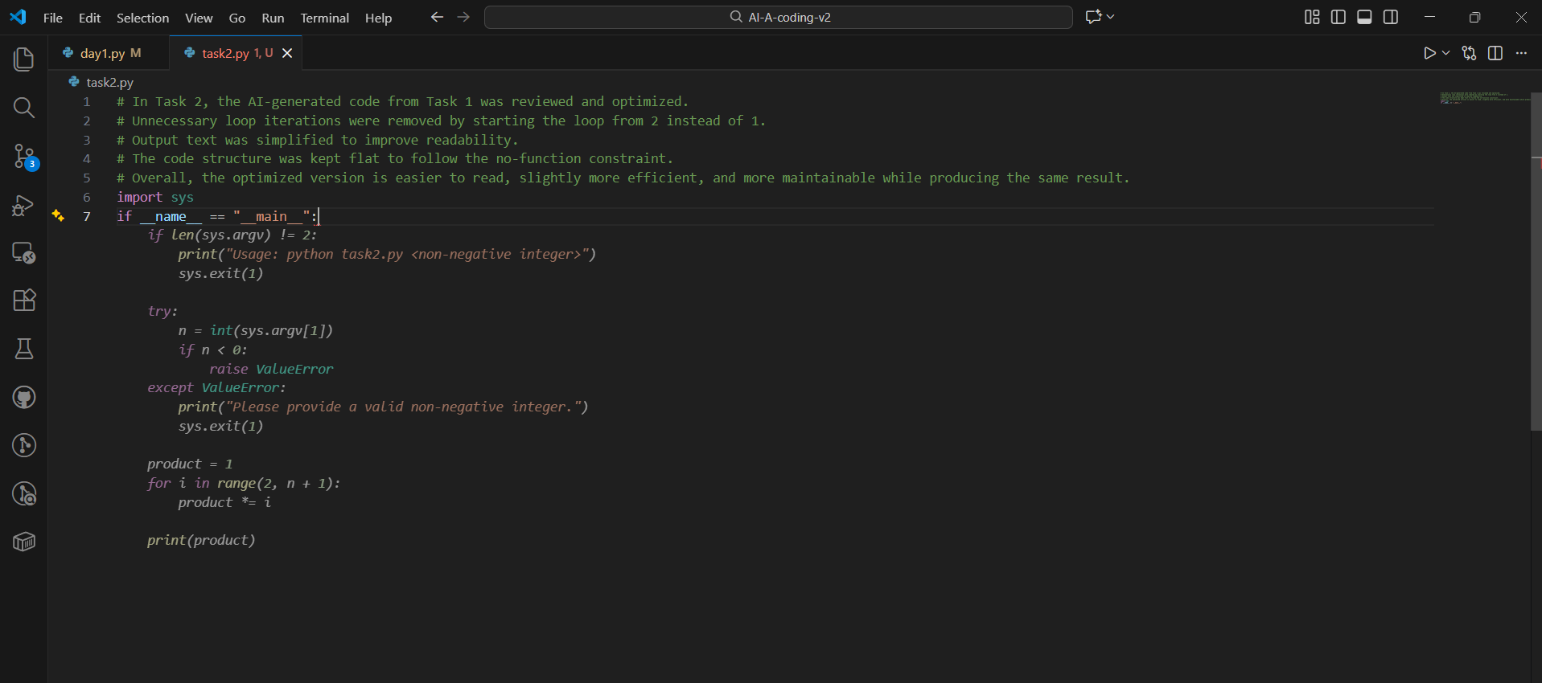
Task 2: AI Code Optimization & Cleanup (Improving Efficiency)
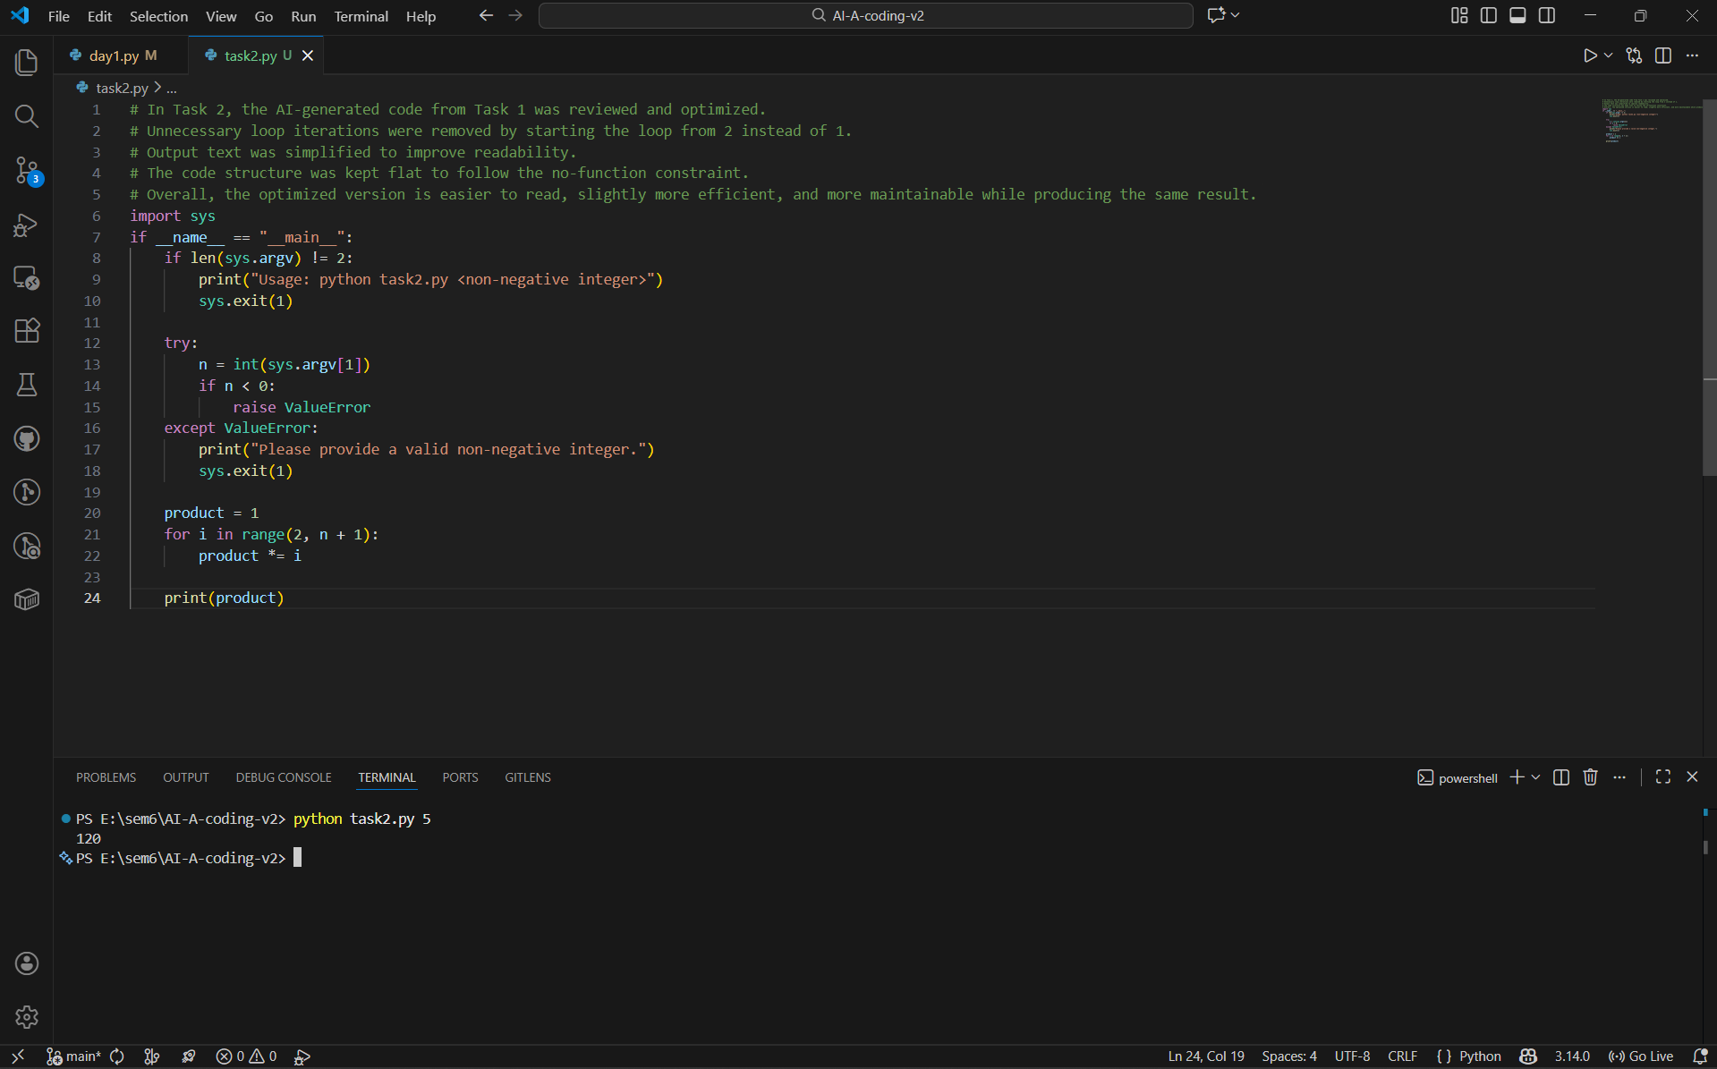

# Task 3: Modular Design Using AI Assistance (Factorial with Functions)

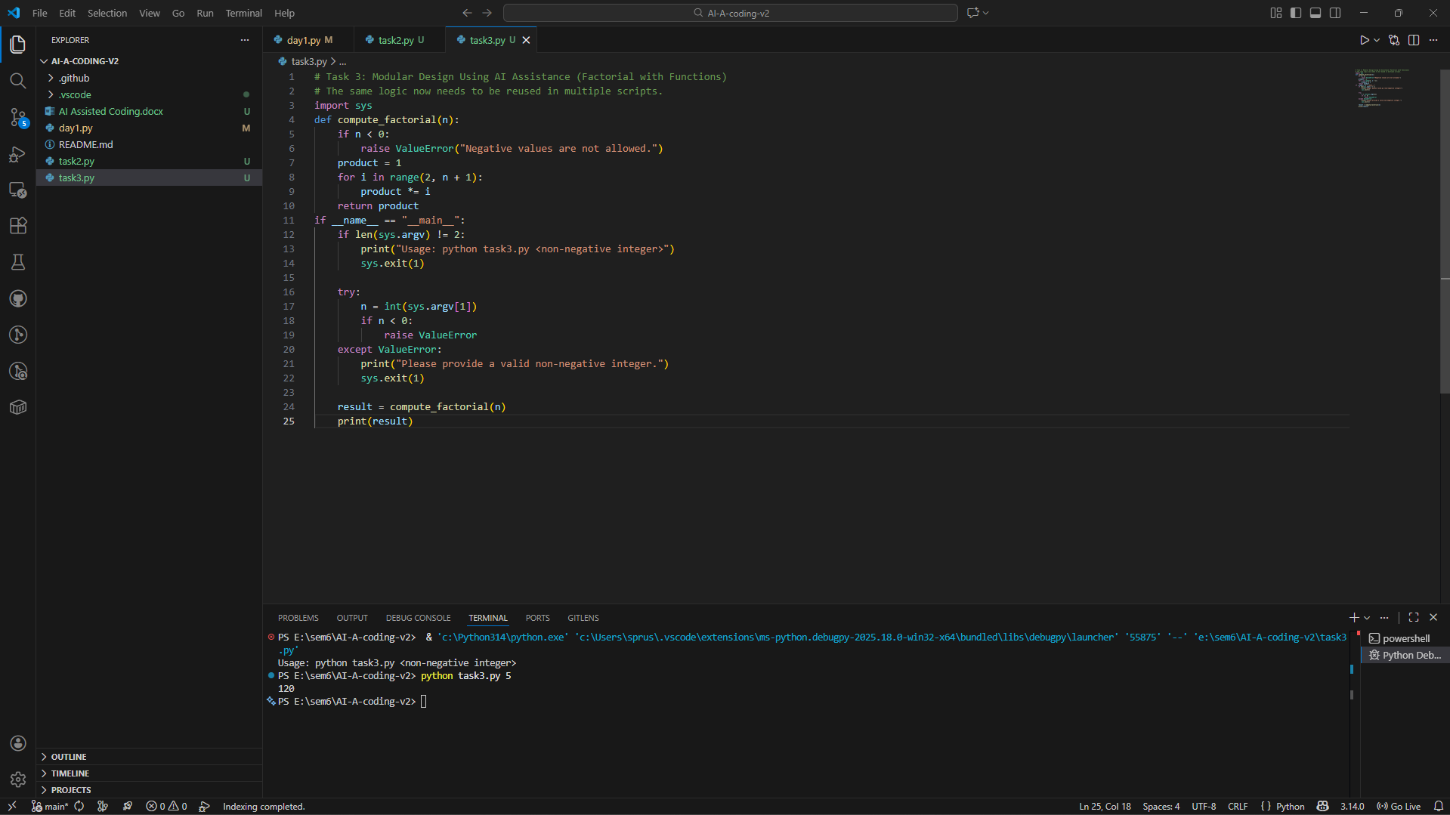

Short Note: How Modularity Improves Reusability
Modularity helps in reusability by helping separate logic in terms of different functions which may be reused in multiple programs. The factorial computation is put in a function which makes the code easier to maintain and test. If the logic has to be changed, changes can be made at one place without having any impact on the whole program. Modular code is also more readable and easier to work on in a team environment.

Task 4: Comparative Analysis – Procedural vs Modular AI Code (With vs
Without Functions)
Criteria | Procedural Code (Without Functions) | Modular Code (With Functions)
Logic Clarity | Logic is written in one continuous flow, which is easy to follow for very small programs but becomes cluttered as code grows. | Logic is clearly separated into functions, making the purpose of each part easier to understand.
Reusability | Code cannot be reused easily because the logic is tightly coupled to the main execution block. | Function-based logic can be reused across multiple scripts by importing or calling the function.
Debugging Ease | Debugging is harder since all logic exists in one block, making it difficult to isolate issues. | Debugging is easier because errors can be traced to specific functions.
Suitability for Large Projects | Not suitable for large projects as it leads to poor organization and low maintainability. | Well suited for large projects due to better structure, scalability, and teamwork support.
AI Dependency Risk | High risk, as beginners may copy AI-generated code without understanding the full flow. | Lower risk, as modular structure encourages understanding of individual components.

Task 5: AI-Generated Iterative vs Recursive Thinking
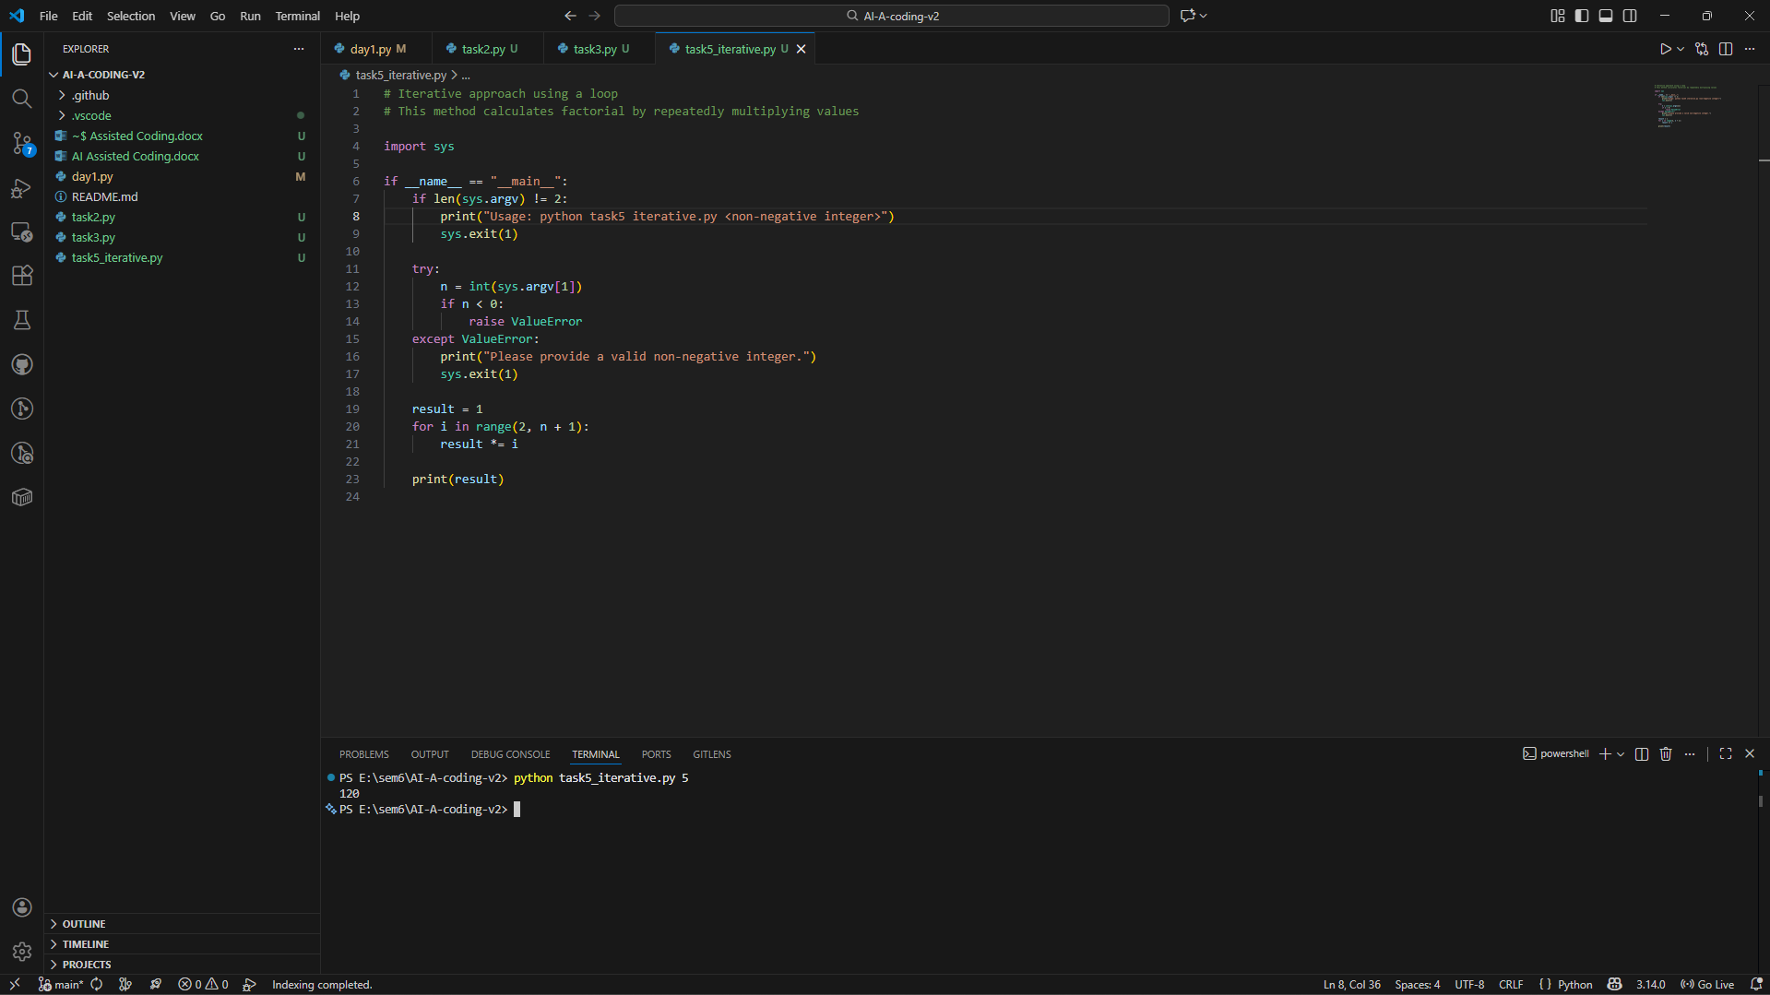
Iterative Thinking -

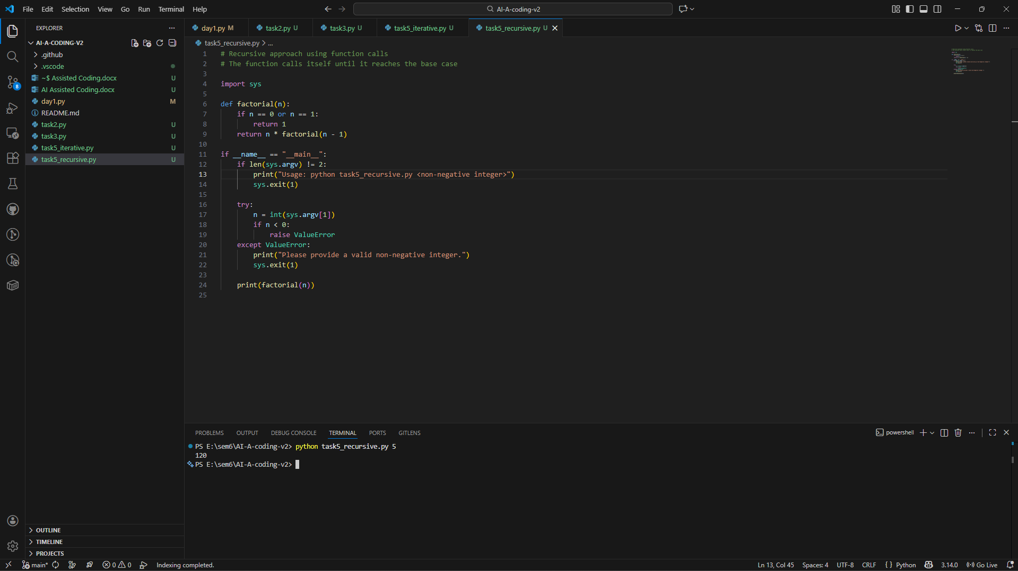
Recursive thinking –

Aspect | Iterative Approach | Recursive Approach
Readability | Easy to understand for beginners | More mathematical and elegant
Stack Usage | Uses constant memory | Uses additional stack memory
Performance | Faster and memory efficient | Slower for large inputs
Error Risk | Low | Risk of stack overflow
When Not Recommended | — | Not recommended for large input values

